DATA BASE

ATTENDACE TABLE

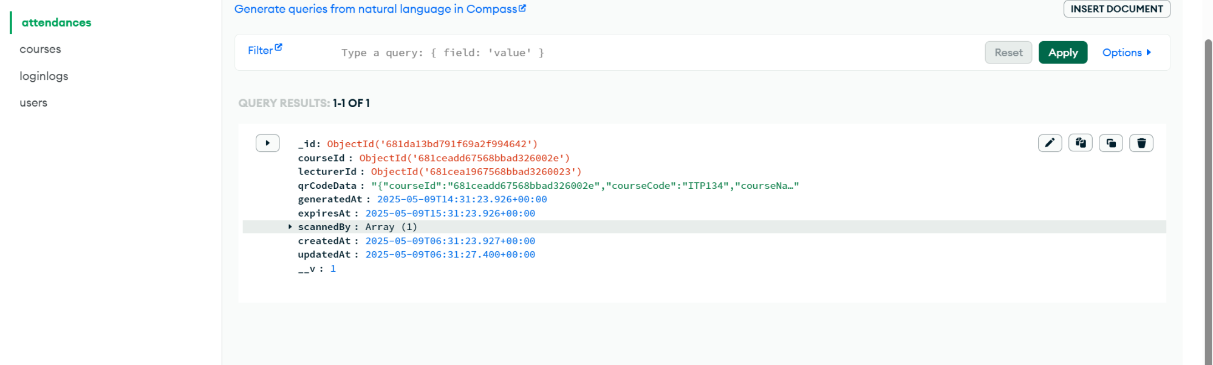

COURSES TABLE

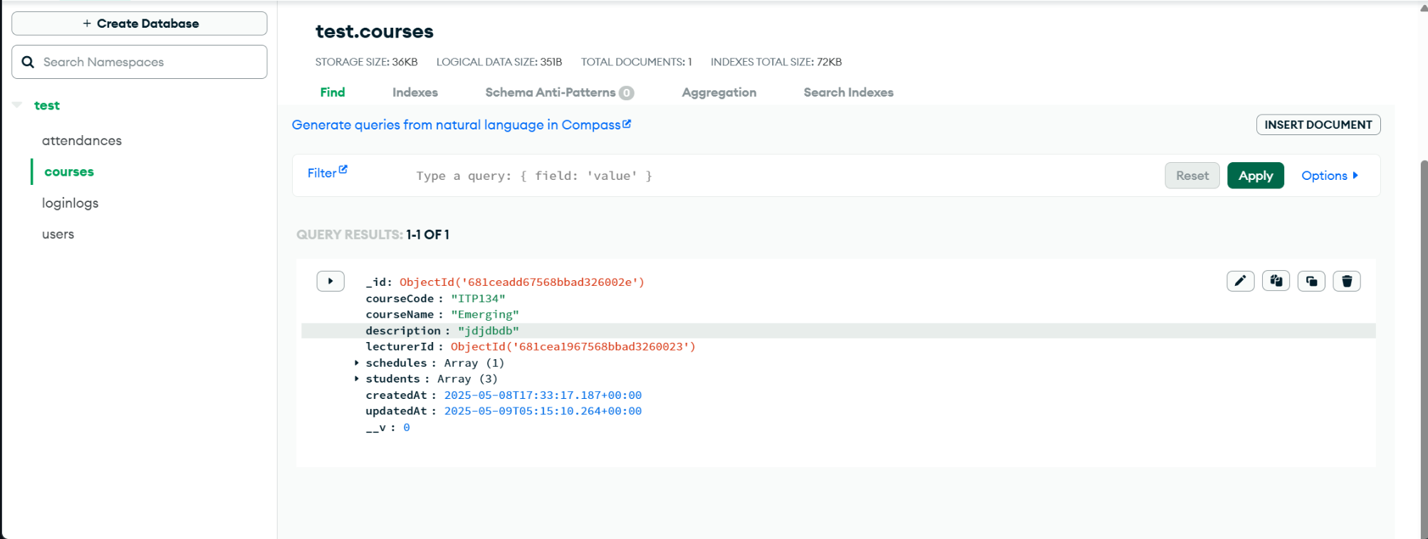

LOGIN L0GS TABLE

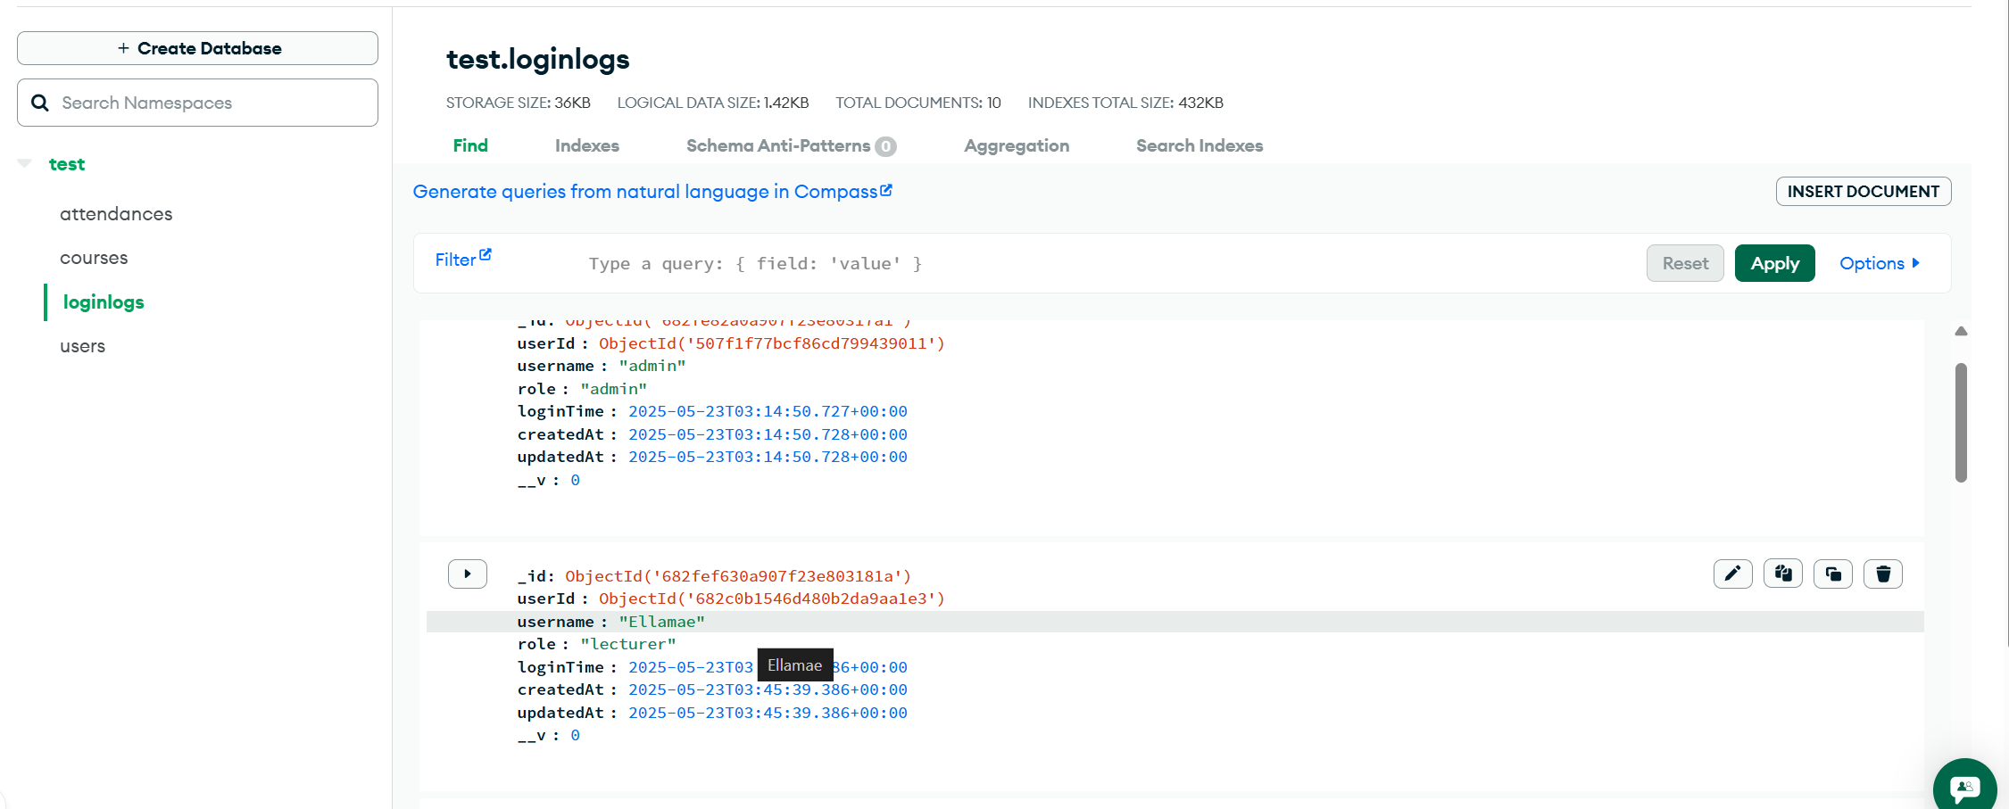

USERS TABLE

